# === Activity on Docker containers ===

Roll Number:20A91A04C4

Name: Y. Meghana

1. Create and launch the Ubuntu 20.0 EC2 or Virtual Machine from cloud provider of your choice.

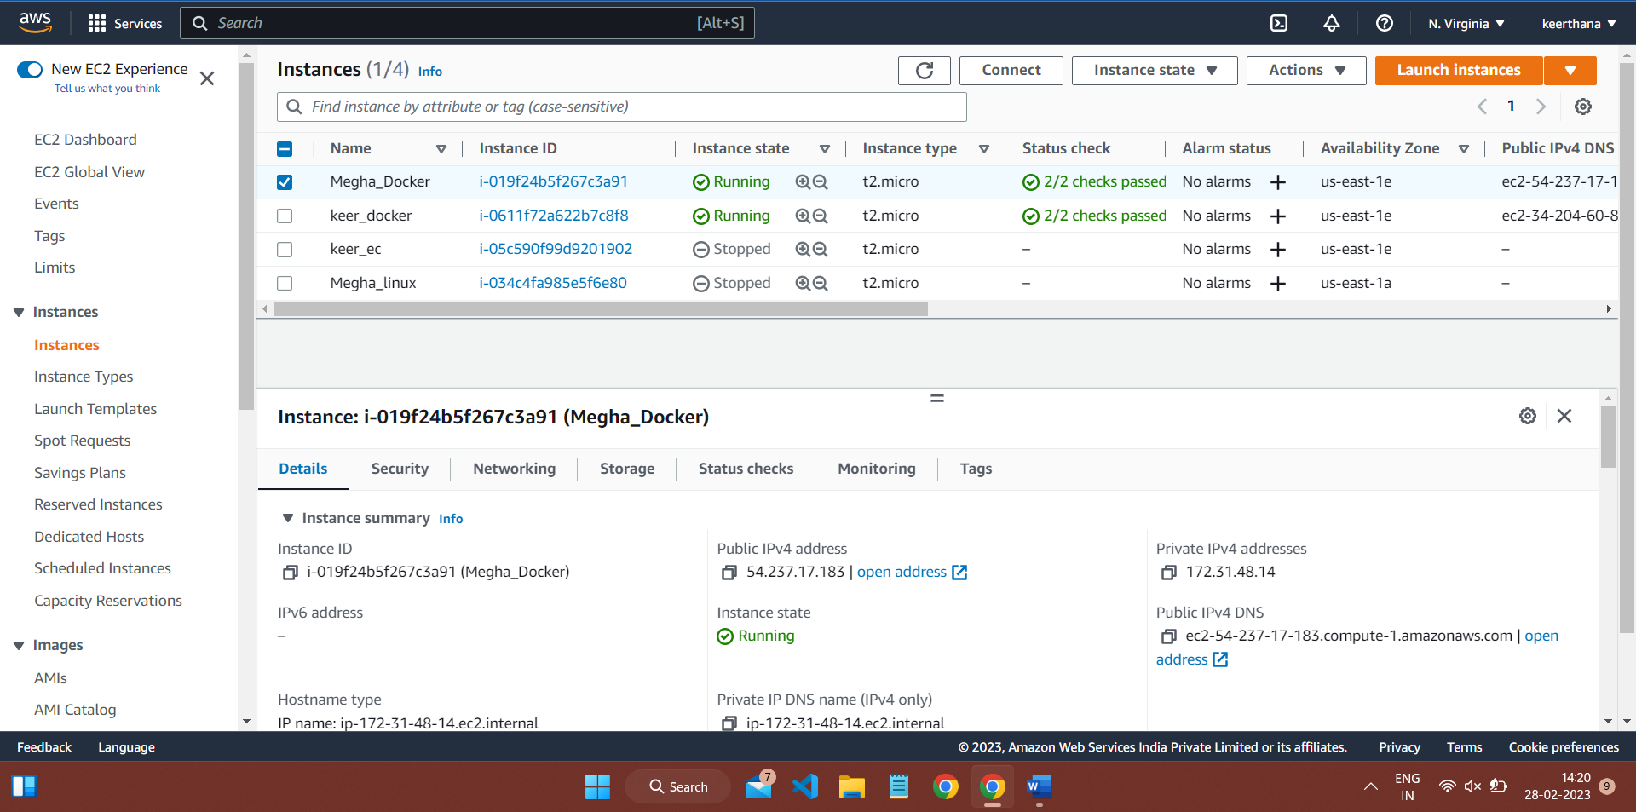

2. Update the ubuntu OS.

Commands:

* sudo su
* sudo apt-get update

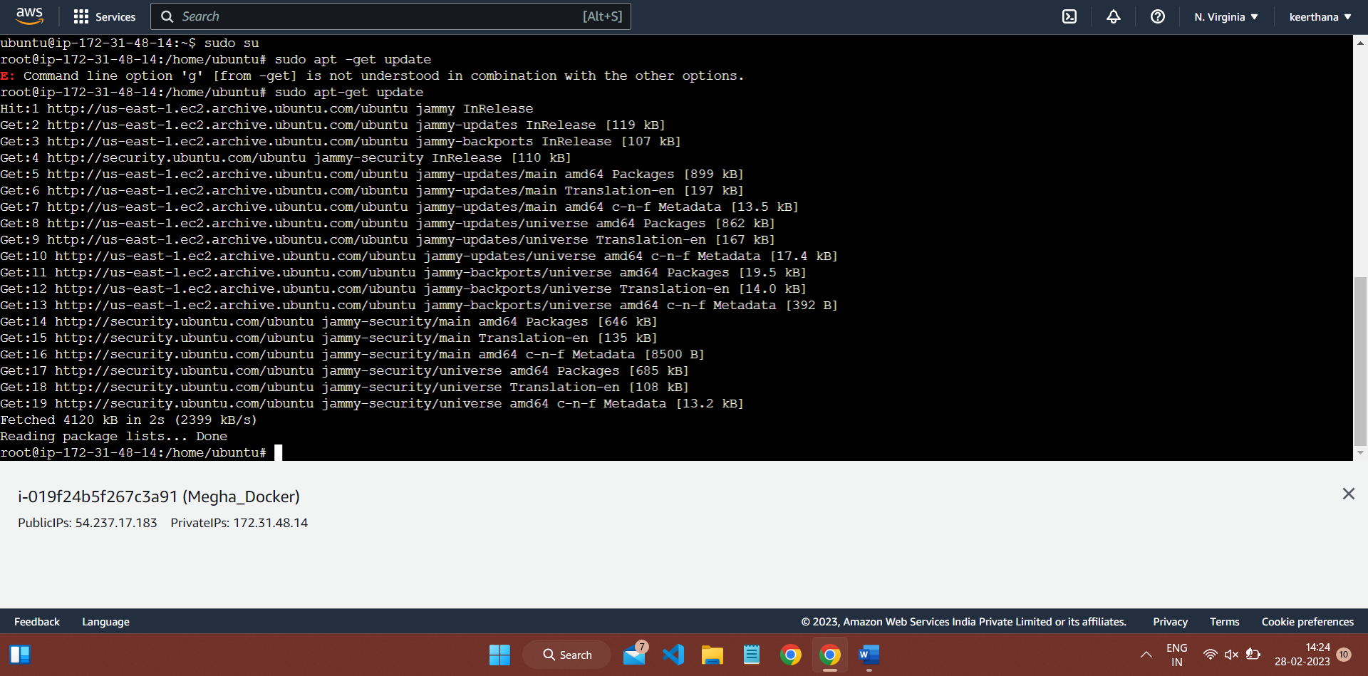

3. Install the docker.

Commands

* sudo apt install docker.io
* docker –version

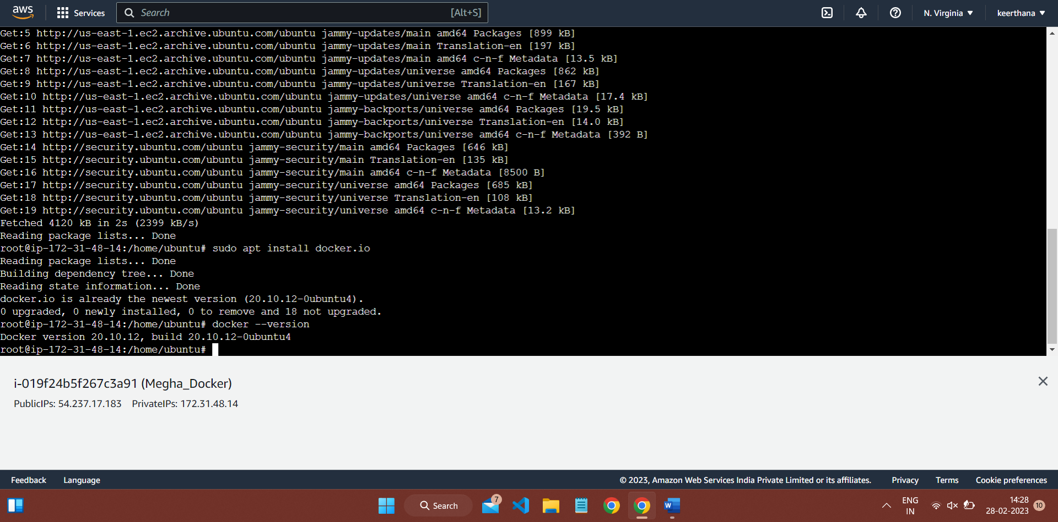

4. Pull the nginx latest image and run the container.

Commands

* docker ps-to check if there are any running images
* docker pull nginx

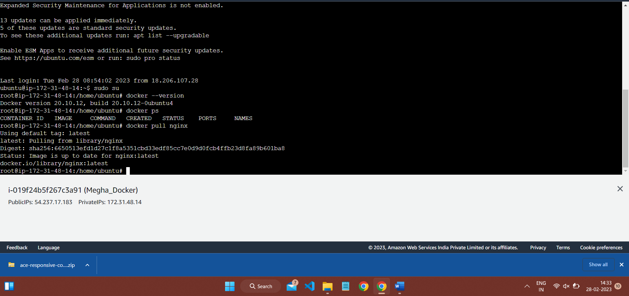

#Created 7000 and 6000 ports docker container (but 6000 port cant be used so at last created another docker container for running parallelly)

Command:

docker run -d -p6000:80 nginx (port is not available)

docker run -d -p7000:80 nginx

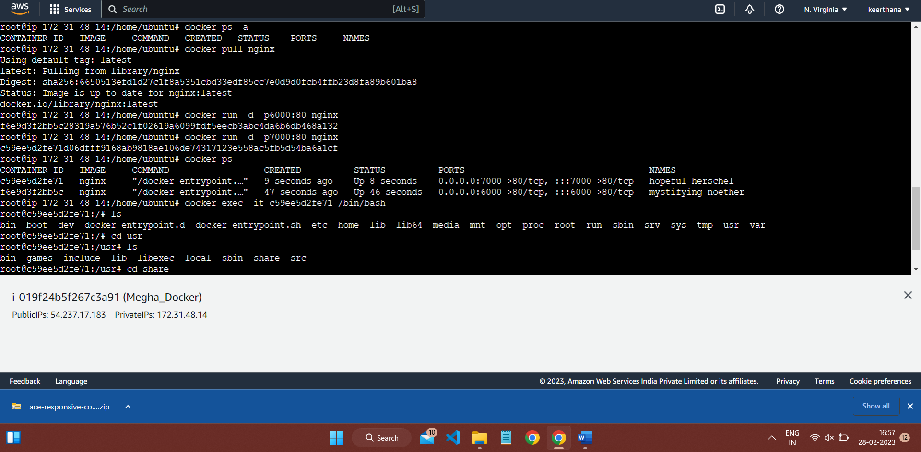

#Executing the container

docker exec -it <container ID> /bin/bash

To get container ID enter docker ps command

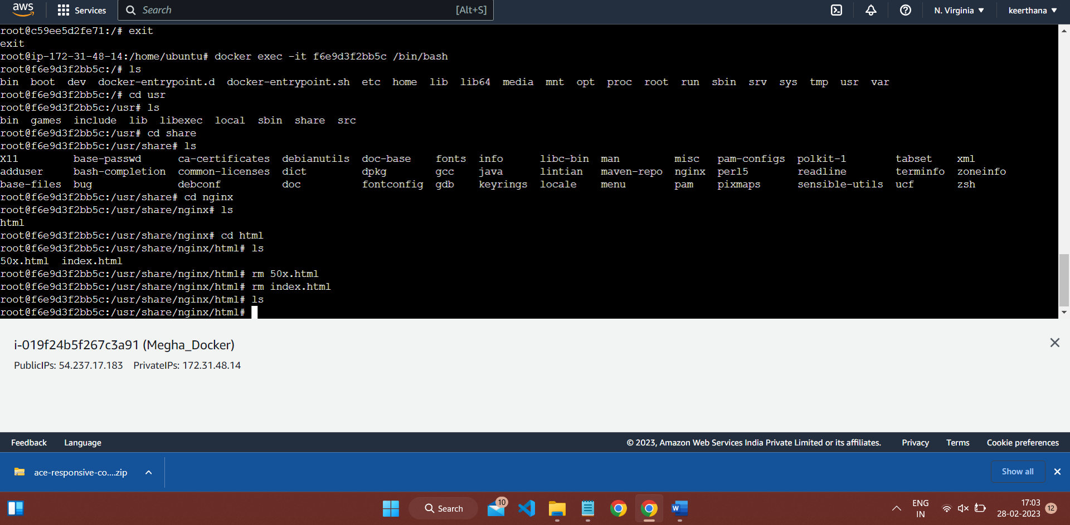

#Pulling the files from github

Command:

git clone <repository link>

git clone https://github.com/Meghana4c4/project.git

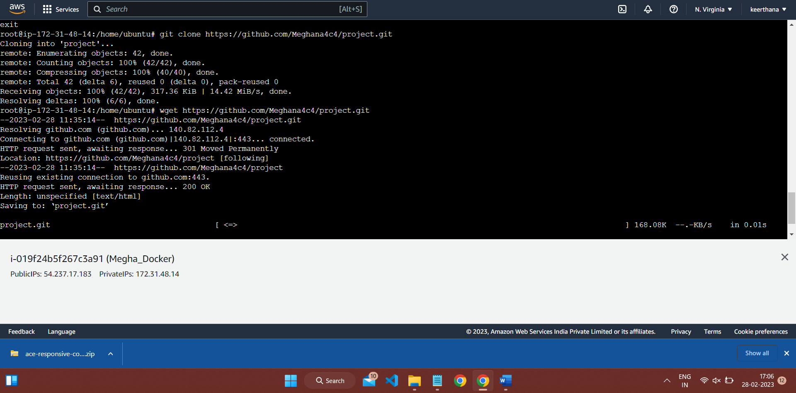

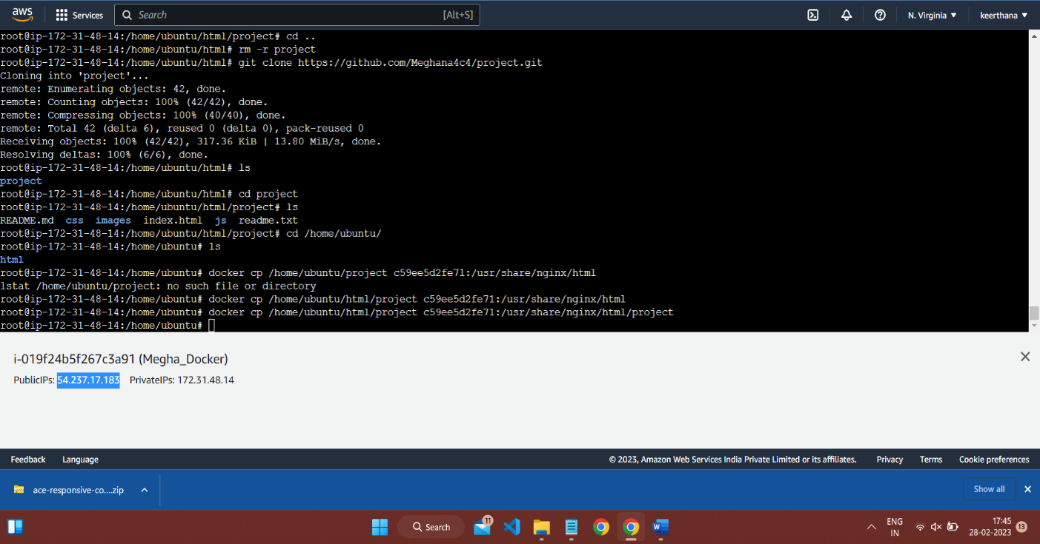#Command:

docker cp <path of the file in ubuntu> <container ID>:</usr/share/nginx/<file you created in ubuntu>

docker cp /home/ubuntu/html/project c59ee5d2fe71:/usr/share/nginx/html/project

#The HTML page in the given repository

PORT:7000

http://54.237.17.183:7000/

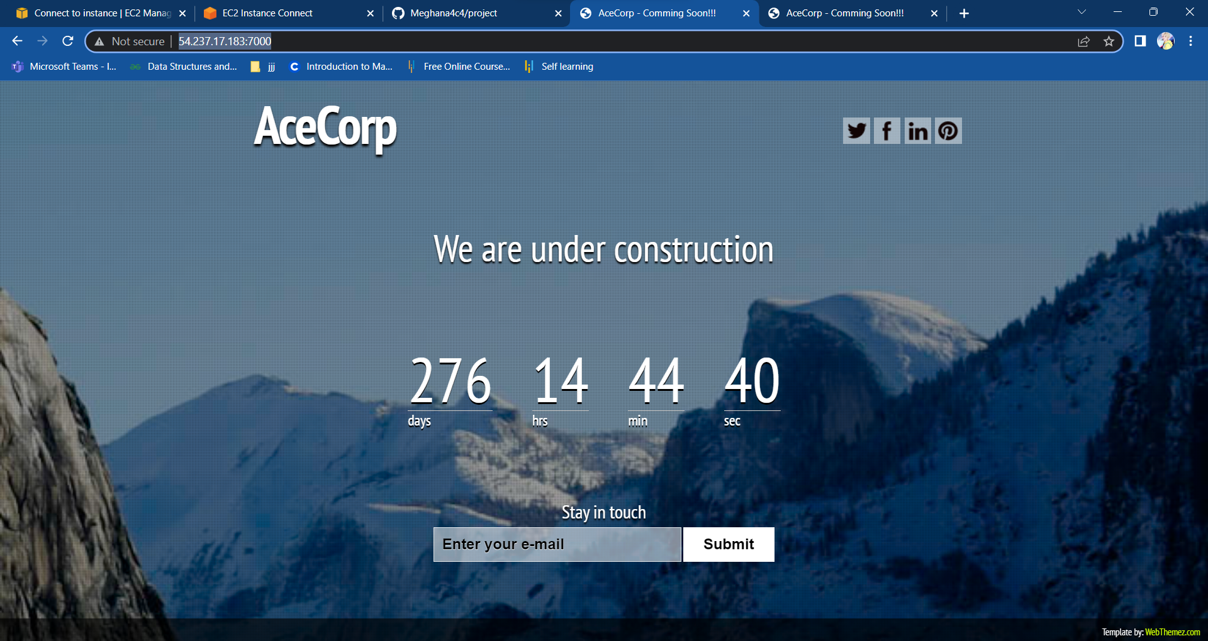

#Creating a new Docker as 6000 PORT is NOT Available

So, making the port 60001

1.Running nginx in 60001 PORT

Command:

docker run -d -p60001:80 nginx

docker ps

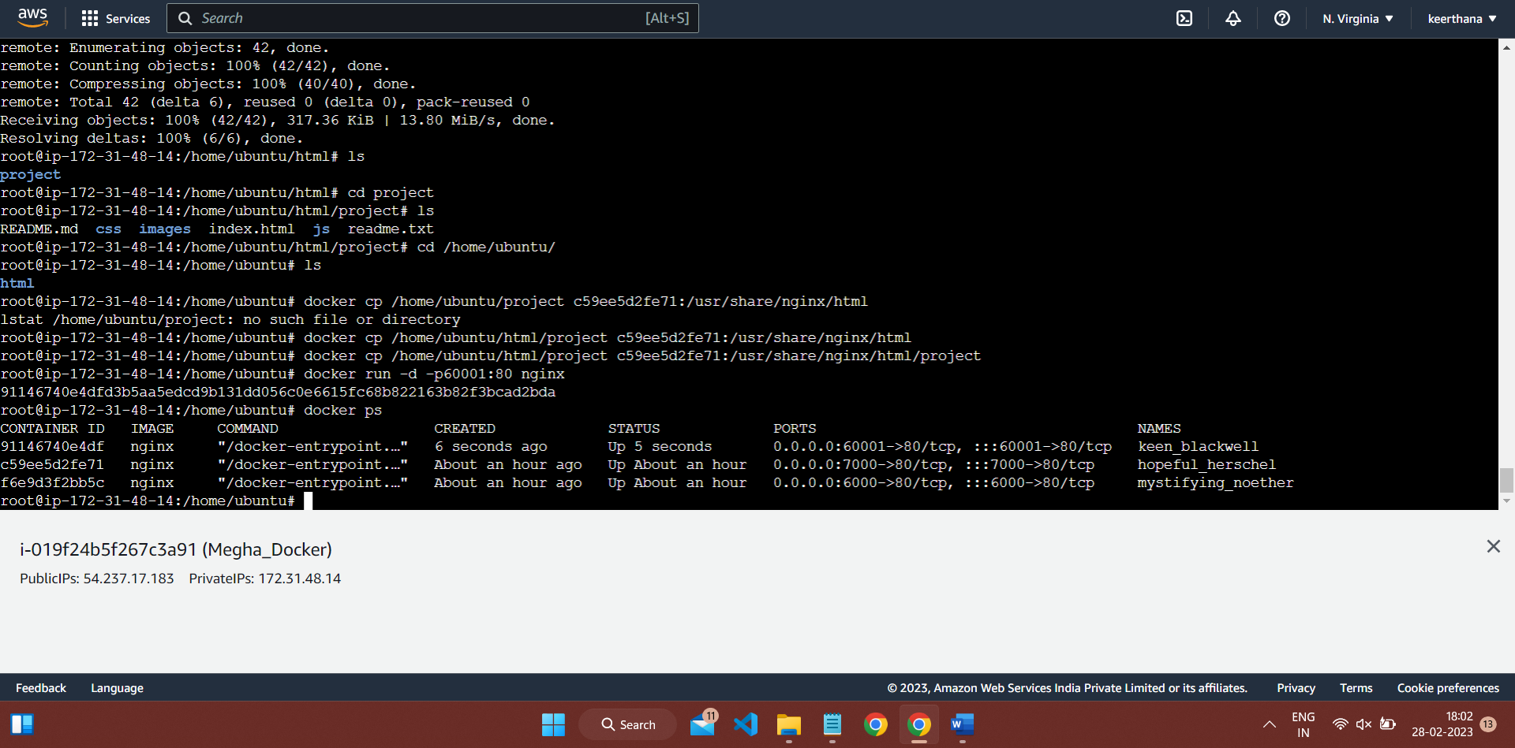

2.removing HTML file

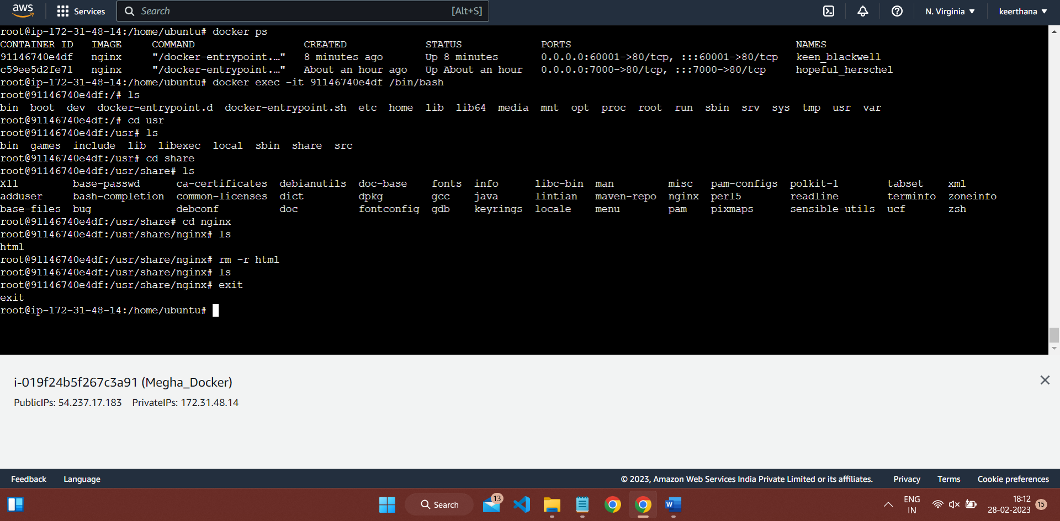

Using rm -r html command

From the path,

cd /usr/share/nginx

3.Copy the path in ubuntu where you cloned the github files

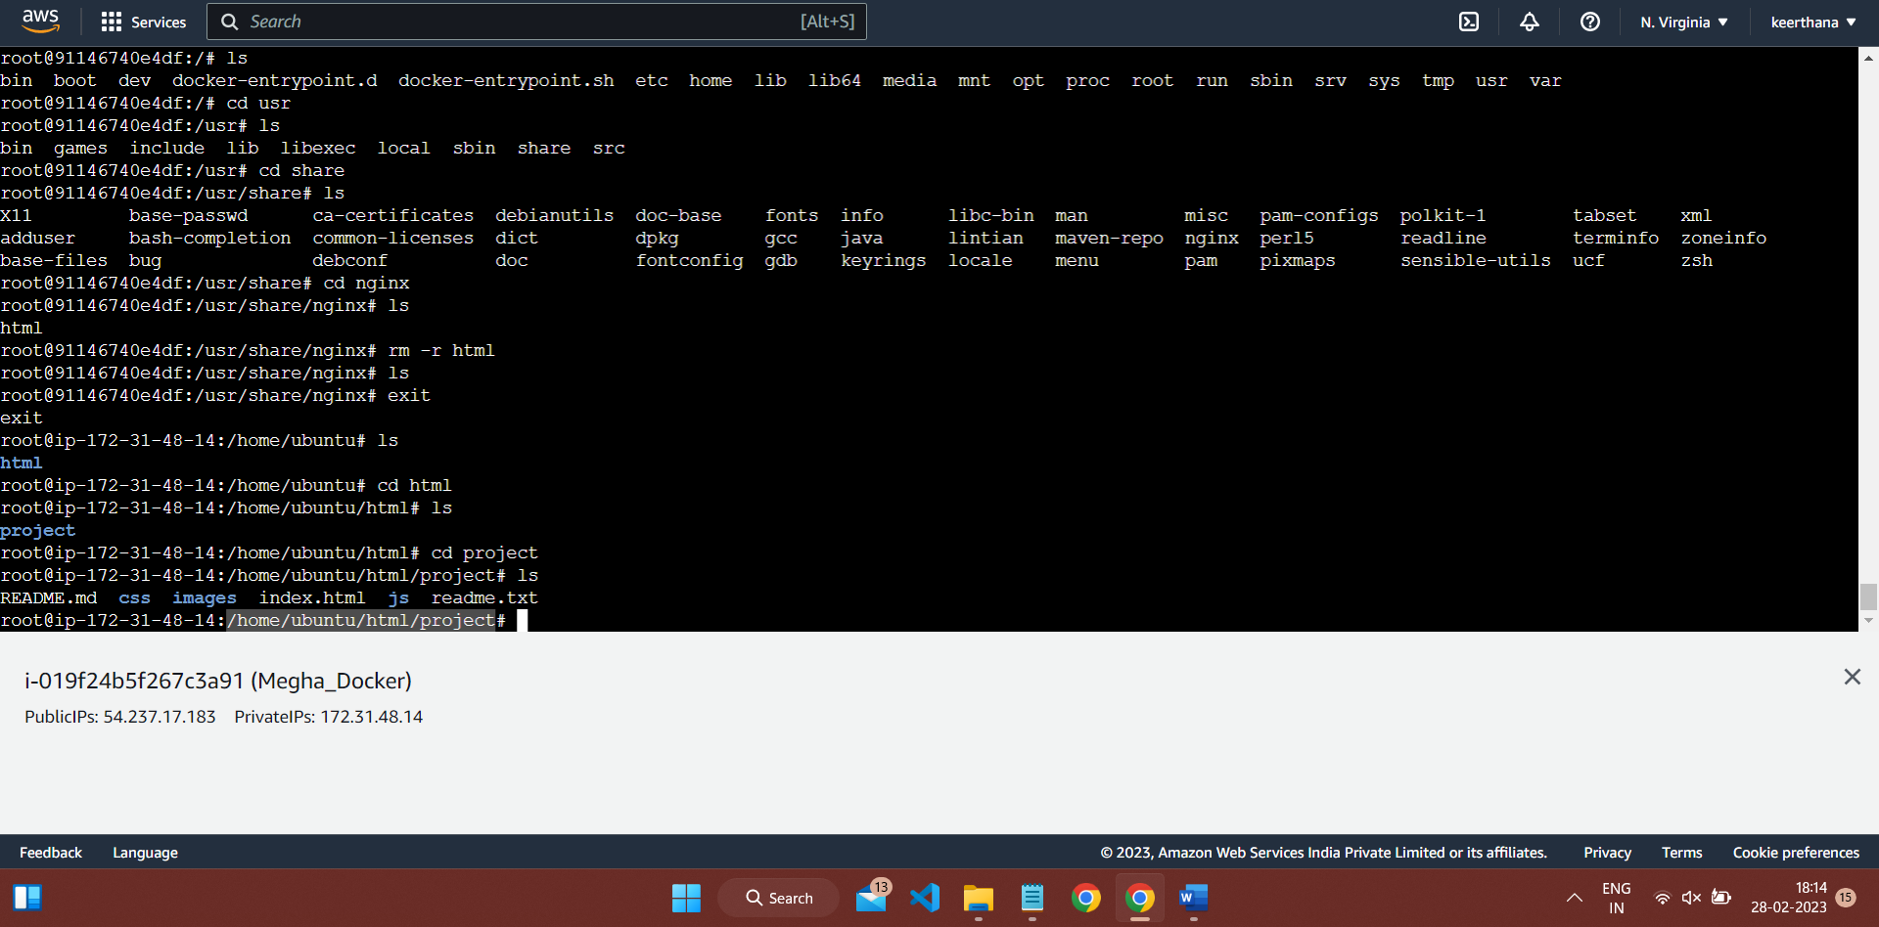

Comeback to home file

Command:

cd /home/ubuntu

#Copying files from UBUNTU to docker container

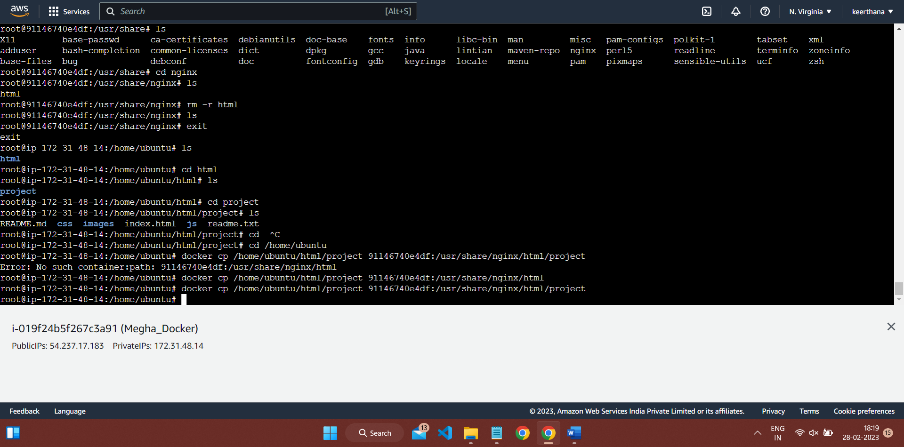

#The HTML page in the given repository

PORT:60001

http://54.237.17.183:60001/

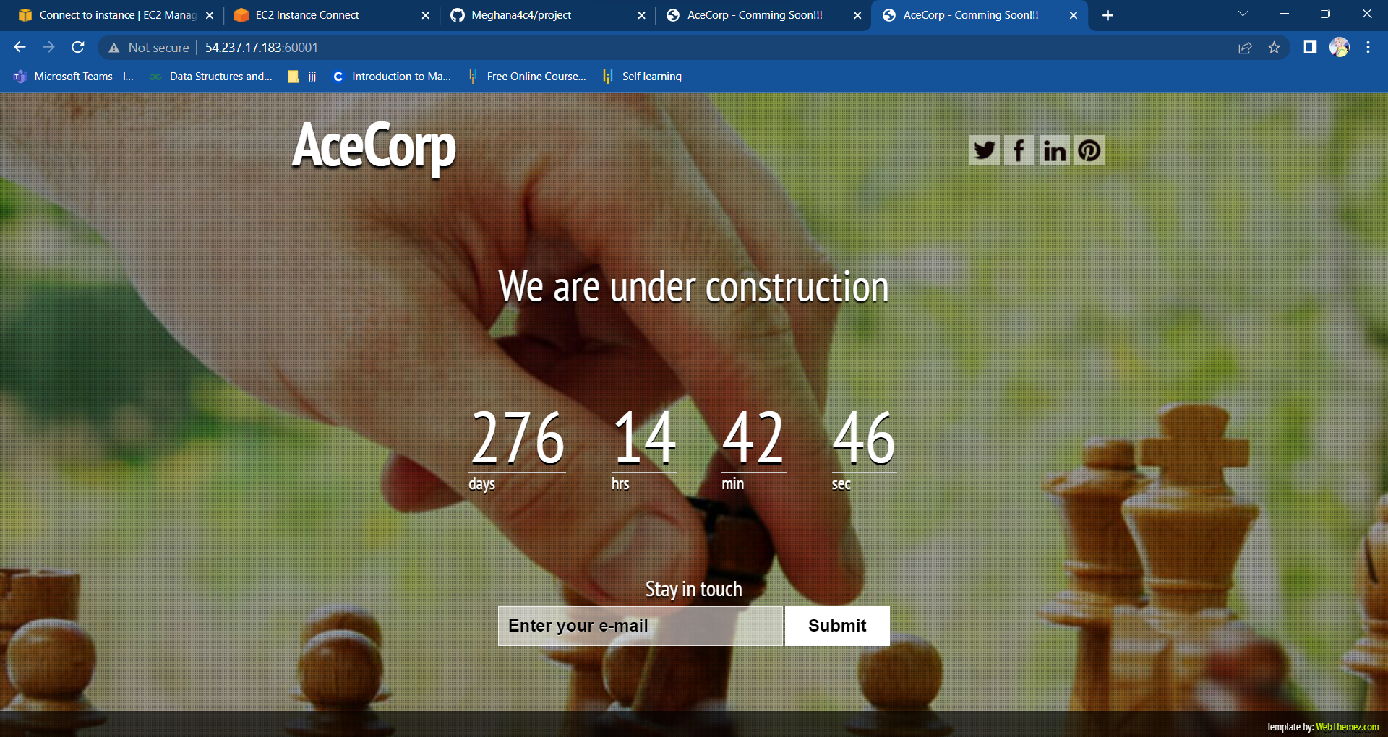

#RUNNING PARALLELLY  
